### 

### IBM Logo PNG | VECTOR - FREE Vector Design - Cdr, Ai, EPS, PNG, SVG

### DATA ANALYTICS PROJECT REPORT- IBM

### (NAAN MUDHALVAN)

**TEAM MEMBERS**

**SARANYA M.N 2021032**

**NANDHINI J 61772121L05**

**GOKULAN S 61772121T302**

**KARPAGAVALLI M 61772121T305**

**NAAN MUDHALVAN TEAM ID -** NM2023TMID21570

**PROJECT TITLE -** Empowering the Future: A Literacy Rate Analysis

for a Better Tomorrow

**TABLE OF CONTENTS**

|  |  |  |  |
| --- | --- | --- | --- |
| **CHAPTER NO.** | **TITLE** | **PAGE NO.** | |
| **1.** | **INTRODUCTION** | | **1** |
|  | 1.1 Project Overview  1.2 Purpose | | 1  2 |
| **2.** | **IDEATION & PROPOSED SOLUTION** | | **2** |
|  | 2.1 Problem Statement Definition | | 2 |
|  | 2.2 Empathy Map Canvas | | 3 |
|  | 2.3 Ideation & Brainstorming  2.4 Proposed Solution | | 4  5 |
| **3.** | **REQUIREMENT ANALYSIS** | | **7** |
|  | 3.1 Functional requirement | | 7 |
|  | 3.2 Non-Functional requirements | | 9 |
| **4.** | **PROJECT DESIGN**  4.1 Data Flow Diagrams  4.2 Solution & Technical Architecture  4.3 User Stories  **CODING & SOLUTIONING** | | **8**  11  12  17  **18** |
|  | 5.1 Feature 1  5.2 Feature 2 | | 18  18 |
| **5**    **6**  **7**  **8**  **9** | **RESULTS**  6.1 Performance Metrics  **ADVANTAGES & DISADVANTAGES**  **CONCLUSION**  **FUTURE SCOPE**  **APPENDIX** | | **19**  19  **20**  **23**  **24**  **26** |

1. **INTRODUCTION**

**1.1 OVERVIEW**

In today's rapidly changing world, education and literacy play a crucial role in shaping the future of individuals and societies alike. A high literacy rate not only empowers individuals to lead fulfilling lives but also serves as a catalyst for economic growth, social development, and overall progress.

Understanding the current status and analyzing the factors influencing literacy rates is essential for designing effective strategies and interventions to improve education systems worldwide. This analysis, titled "Empowering the Future: A Literacy Rate Analysis for a Better Tomorrow," aims to delve into the intricacies of literacy rates, uncover underlying trends, and identify key factors that impact literacy levels across different regions and demographics.

By examining a wide range of data sources, including national surveys, educational reports, and demographic indicators, this analysis seeks to provide a comprehensive understanding of the global literacy landscape. It will explore not only the overall literacy rates but also dive deeper into subcategories such as gender, age groups, and socioeconomic backgrounds to uncover any disparities or patterns that may exist.

The analysis will employ advanced data analytics techniques to extract valuable insights and trends from the available data. By employing statistical analysis and data visualization, the study aims to present a clear and compelling picture of the literacy situation across different regions and demographics.

The ultimate goal of this analysis is to contribute to the efforts of policymakers, educators, and stakeholders in creating effective strategies and policies to enhance literacy rates and promote equal access to education. By shedding light on the challenges and opportunities surrounding literacy, this study strives to empower decision-makers with the knowledge needed to shape educational policies and initiatives that will pave the way for a better tomorrow.

Through this comprehensive exploration of literacy rates, "Empowering the Future: A Literacy Rate Analysis for a Better Tomorrow" aims to inspire action, foster collaboration, and ignite a collective commitment to ensuring that every individual has the opportunity to acquire the vital skill of literacy.

**1.2 PURPOSE**

Understand the Current State of Literacy: The analysis aims to provide an in-depth understanding of the literacy rates globally, including variations across regions, age groups, genders, and socioeconomic backgrounds. By examining the current state of literacy, the study seeks to identify gaps and challenges that need to be addressed to improve educational outcomes.

**Identify Factors Influencing Literacy Rates:** The analysis aims to identify and analyze the factors that influence literacy rates. By examining variables such as access to education, quality of education, socioeconomic factors, and cultural influences, the study seeks to uncover key drivers behind literacy levels. This information can guide policymakers and educators in formulating targeted interventions and policies to improve literacy rates.

**Uncover Disparities and Inequalities:** The analysis will explore any disparities or inequalities in literacy rates among different groups, such as gender, age, and socioeconomic status. By highlighting these disparities, the study aims to draw attention to the importance of addressing educational inequalities and promoting inclusive and equitable access to education for all individuals.

**Inform Policy and Decision Making:** The analysis aims to provide evidence-based insights to inform policy and decision-making processes related to education. By presenting a comprehensive analysis of literacy rates and associated factors, policymakers, educators, and stakeholders can make informed decisions regarding resource allocation, curriculum development, teacher training, and other initiatives aimed at improving literacy rates.

**Inspire Action and Collaboration:** By shedding light on the critical issue of literacy, the analysis seeks to inspire action and foster collaboration among various stakeholders. It aims to encourage policymakers, educators, community organizations, and individuals to come together to develop innovative solutions, share best practices, and work towards a collective goal of improving literacy rates worldwide.

Overall, the purpose of "Empowering the Future: A Literacy Rate Analysis for a Better Tomorrow" is to generate knowledge, raise awareness, and drive positive change in the field of education by empowering individuals and societies through increased literacy and access to quality education.

1. **IDEATION & PROPOSED SOLUTION**

**2.1 PROBLEM STATEMENT DEFINITION**

Despite the world's progress towards achieving universal literacy, many countries still struggle with low literacy rates, which have negative impacts on their economic, social, and political development. Therefore, there is a need to analyze the current state of literacy rates globally and identify the key factors that contribute to high or low rates of literacy. This analysis will provide insights and recommendations for policymakers, educators, and stakeholders to improve literacy rates and create a more prosperous and equitable future for all.

**2.2 EMPATHY MAP CANVAS**

**2.3 IDEATION AND BRAINSTROMING**

**Brainstorm, Idea Listing and Grouping**

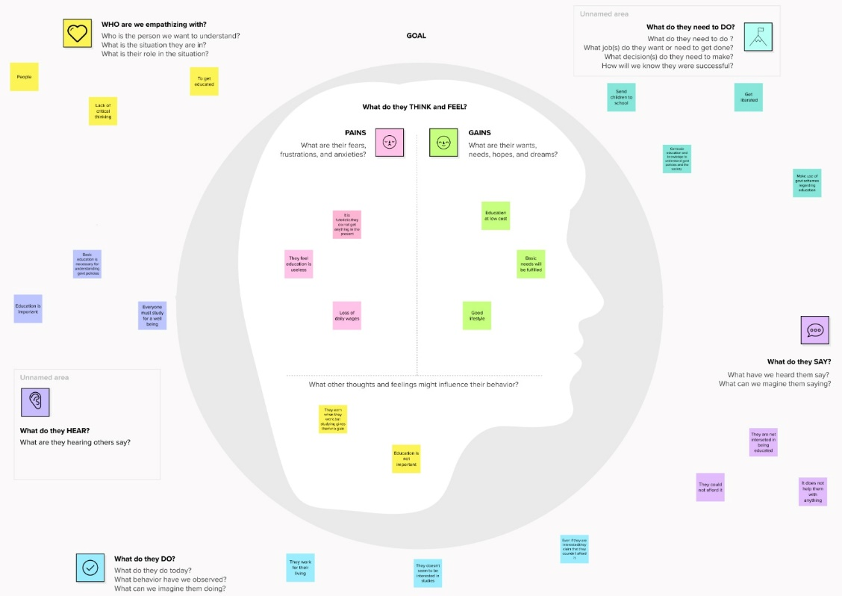

**Idea prioritization**

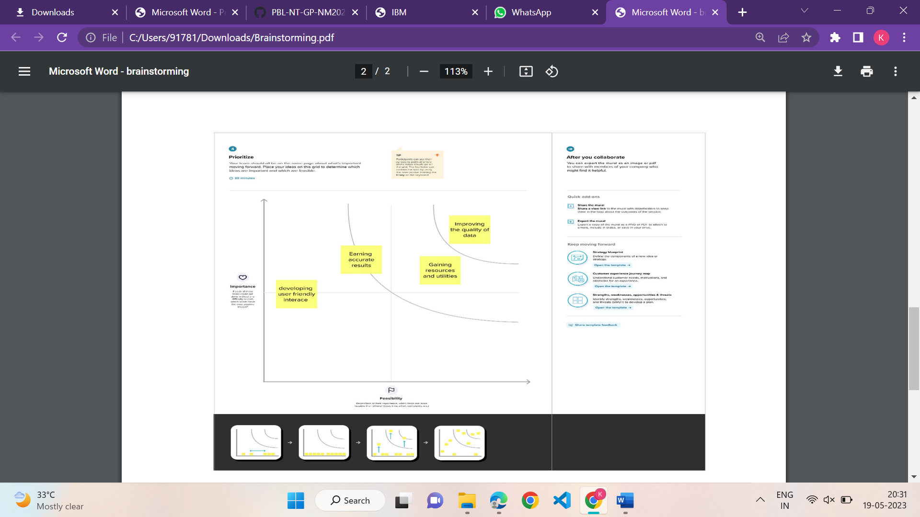

**2.4 PROPOSED SOLUTION**

**Problem Statement (Problem to be solved)**

Despite the world's progress towards achieving universal literacy, many countries still struggle with low literacy rates, which have negative impacts on their economic, social, and political development. This analysis will provide insights and recommendations for policymakers, educators, and stakeholders to improve literacy rates and create a more prosperous and equitable future for all.

**Feasibility of Idea**

The use of Statistical tools, such as regression analysis and data visualization, can be used to analyze the data and identify patterns and trends. Data can be collected from various sources, such as national statistical agencies and academic research, to provide a comprehensive understanding of the current state of literacy rates globally**.**

**Novelty / Uniqueness**

This projects solely focus on analyzing the current state of literacy rates globally, it goes beyond by developing targeted strategies and programs to address the unique needs of different communities and promote equal access to quality education for all. It also recognizes the importance of early childhood education and literacy programs in improving literacy rates and empowering individuals.

**Social Impact / Customer Satisfaction**

By improving literacy rates and empowering individuals and communities, the project can contribute to reducing poverty, increasing economic growth, and promoting social inclusion. This can have a ripple effect on other social issues, such as healthcare, gender equality, and environmental sustainability.

**Business Model (Revenue Model)**

The business model is centered around securing funding and resources to support its goals. It helps to collaborate with non-profit organizations, private donors, and government agencies to secure funding and resources to support its initiatives. The project can also develop partnerships with businesses, educational publishers, ed-tech companies, and other organizations that have a vested interest in promoting literacy and education.

**Scalability of the Solution**

The project's initiatives and recommendations can be tailored to meet the specific needs of different regions and populations, such as rural or urban communities, low-income populations, or ethnic minority groups. This can be achieved through partnerships and collaborations with local organizations, educators, and policymakers to identify the unique challenges and develop customized solutions.

1. **REQUIREMENT ANALYSIS**

**3.1 Functional requirement**

**Data Collection and Preparation:**

a. Identify relevant data sources for literacy rates, demographic information, and educational resources.

b. Collect and compile data from multiple sources into a unified dataset.

c. Perform data cleaning and validation to ensure data accuracy and consistency.

d. Transform and standardize data formats for efficient analysis.

**Exploratory Data Analysis:**

a. Conduct exploratory data analysis to understand the structure and characteristics of the dataset.

b. Identify missing values, outliers, and inconsistencies in the data.

c. Explore relationships between variables to uncover initial insights and patterns.

d. Visualize data through charts, graphs, and other visual representations to facilitate understanding.

**Statistical Analysis:**

a. Apply statistical techniques to analyze relationships, trends, and patterns within the dataset.

b. Conduct descriptive statistics to summarize the key metrics and characteristics of literacy rates.

c. Perform inferential statistics to test hypotheses, compare groups, and identify statistically significant findings.

d. Use regression analysis or other predictive modeling techniques to identify factors influencing literacy rates.

**Geographic Analysis:**

a. Utilize geographic information systems (GIS) to analyze spatial patterns of literacy rates.

b. Map literacy rates by region, district, or other geographical units.

c. Identify hotspots or areas with high or low literacy rates.

d. Analyze the relationship between literacy rates and geographical factors such as access to educational facilities or socioeconomic conditions.

**Time Series Analysis:**

a. Analyze trends and changes in literacy rates over time.

b. Apply time series modeling techniques to forecast future literacy rates.

c. Identify seasonality, trends, and irregularities in literacy rate data.

**Demographic Analysis:**

a. Analyze literacy rates across different demographic variables such as age, gender, ethnicity, or socioeconomic status.

b. Identify disparities and inequalities in literacy rates among different demographic groups.

c. Explore the relationship between demographic factors and literacy outcomes.

d. Provide recommendations for targeted interventions based on demographic analysis.

**Data Visualization and Reporting:**

a. Create visualizations (charts, graphs, maps) to present analysis results in a clear and meaningful manner.

b. Develop interactive dashboards for stakeholders to explore data and insights.

c. Generate comprehensive reports summarizing the analysis findings and recommendations.

d. Present findings to stakeholders through presentations or other communication channels.

**Data Privacy and Security:**

a. Ensure the protection of sensitive data and comply with relevant data privacy regulations.

b. Implement data anonymization techniques to protect individual privacy.

c. Establish secure data storage and access protocols to prevent unauthorized use or breaches.

**Collaboration and Integration:**

a. Collaborate with domain experts, policymakers, and other stakeholders to understand their requirements and incorporate their insights into the analysis.

b. Integrate data analytics with existing systems or platforms to facilitate data sharing and decision-making processes.

c. Coordinate with data providers to ensure data accessibility and accuracy throughout the project.

**Documentation and Knowledge Transfer:**

a. Document the methodologies, processes, and algorithms used in the analysis.

b. Create user guides and documentation to enable knowledge transfer and support future maintenance of the project.

c. Conduct training sessions or workshops to enhance stakeholders' understanding of the analysis results and how to leverage them effectively.

**Performance and Scalability:**

a. Optimize data processing and analysis algorithms for efficient and timely results.

b. Consider scalability requirements to accommodate larger datasets or future expansions of the project.

c. Monitor

**3.2 Non-Functional requirements**

Performance:

a. The system should provide fast and responsive data processing and analysis to ensure efficient decision-making.

b. The analysis should be completed within a reasonable timeframe to meet project deadlines.

c. The system should be able to handle large volumes of data without significant performance degradation.

Reliability:

a. The data analytics processes should be accurate and reliable, producing consistent and valid results.

b. The system should be robust and able to handle unexpected data inputs or errors without failure.

c. Measures should be in place to ensure data integrity and prevent data corruption or loss.

Scalability:

a. The system should be designed to accommodate increasing amounts of data and growing user demands.

b. It should be capable of handling future expansions or additions of data sources without significant modifications.

Security:

a. Data confidentiality should be ensured through appropriate access controls and encryption mechanisms.

b. The system should adhere to relevant data privacy regulations and industry best practices.

c. Measures should be in place to prevent unauthorized access, data breaches, or data leaks.

Usability:

a. The system should have a user-friendly interface, allowing users to easily interact with the data and analysis results.

b. The visualizations and reports should be intuitive and understandable for non-technical stakeholders.

c. The system should provide appropriate documentation, user guides, and training materials to facilitate user adoption.

Maintainability:

a. The code and infrastructure should be well-documented and organized to facilitate future maintenance and enhancements.

b. The system should be modular and extensible, allowing for easy updates or modifications in response to changing requirements.

c. Regular monitoring and maintenance procedures should be in place to identify and address any performance or security issues.

Interoperability:

a. The system should be able to integrate with existing data sources, systems, or platforms to facilitate data exchange and interoperability.

b. It should support standard data formats and protocols to ensure compatibility with external tools or applications.

Compliance:

a. The project should adhere to relevant legal, ethical, and regulatory requirements related to data privacy, data protection, and research ethics.

b. Any data collection or analysis processes involving human subjects should follow ethical guidelines and obtain necessary approvals.

Collaboration and Communication:

a. The system should facilitate collaboration and communication among project team members, enabling efficient sharing of insights, findings, and progress updates.

b. It should support version control and collaboration tools to manage and track changes made by multiple team members.

Disaster Recovery:

a. The system should have backup and recovery mechanisms in place to ensure data availability in the event of system failures or disasters.

b. Regular data backups should be performed to prevent data loss or corruption.

Cost-Effectiveness:

a. The project should be implemented in a cost-effective manner, optimizing resource utilization without compromising the quality of analysis and deliverables.

b. Considerations should be given to the cost of data acquisition, infrastructure, software licenses, and human resources required for the project.

**4. PROJECT DESIGN**

Project design is the process of planning and organizing a project from start to finish in a clear and logical manner. It involves defining project objectives, determining the tasks and activities required to achieve those objectives, and outlining the resources, timeline, and steps needed to complete the project successfully.

**4.1 Data Flow Diagrams**

A Data Flow Diagram (DFD) is a traditional visual representation of the information flows within a system. A neat and clear DFD can depict the right amount of the system requirement graphically. It shows how data enters and leaves the system, what changes the information, and where data is stored.

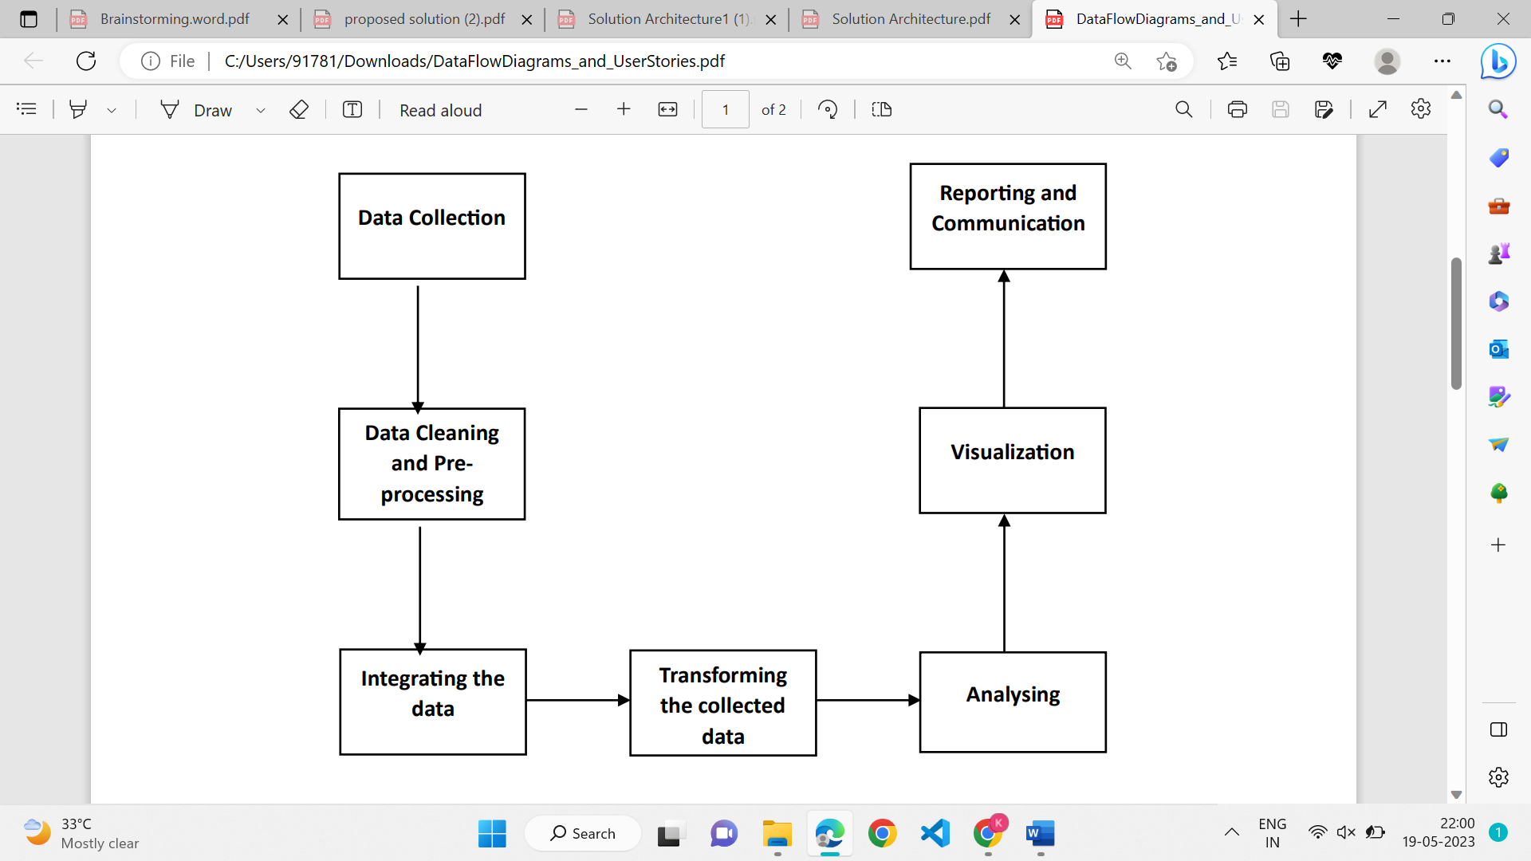

*DFD (Empowering the Future: A literacy Rate Analysis for a Better Tomorrow)*

**4.2 Solution and Technical Architecture:**

**Our solution**:

Statistical analysis tools, data visualization software, and programming

Languages.

**Structure:**

* **Define the research question:**

Start by defining the research question that the literacy rate analysis project will address

* **Gather data:**

Collecting data on literacy rates, as well as any other relevant data that may help to answer the research question.

* **Clean and process data:**

Data will need to clean and process it to prepare it for analysis. This may involve removing duplicates and outliers, dealing with missing data

* **Analyze the data:**

Use statistical analysis tools to analyze the data and explore relationships between different variables.

* **Interpretation and Visualization:**

The results of the model are interpreted and visualized to provide insights into the features.

* + - **Communicate the findings:**

This may involve writing a report, creating a presentation, or sharing results through other channels.

**Characteristics:**

* This may draw on multiple disciplines, such as education, economics, sociology, and statistics, to provide a comprehensive understanding of literacy rates and their determinants.
* This will rely heavily on data to identify patterns and relationships between different variables. The analysis may involve collecting, cleaning, and processing large amounts of data from various sources.

**Behaviour:**

* It evaluate the effectiveness of different education policies and identify which policies have the greatest impact on literacy rates. This can inform future policy decisions and help to improve education systems.
* It can demonstrate the economic and social benefits of investing in education, which can encourage policymakers to allocate more resources to education and literacy programs.

**Features:**

* Multidisciplinary approach
* Data-driven
* Contextual
* Collaborative
* Evidence-based
* Policy-relevant

**Development Phases:**

* Define the research question
* Review the literature
* Collect data
* Clean and prepare the data
* Analyze the data
* Communicate the results

**Solution Requirements:**

* Data collection and management tools
* Statistical analysis software
* Visualization tools
* Collaborative tools
* policy analysis frameworks
* Evaluation tools

**Specifications:**

* Research question
* Data sources:
* Variables
* Sampling
* Data analysis
* Visualization
* policy recommendations

**Solution / Technical Architecture Diagram:**

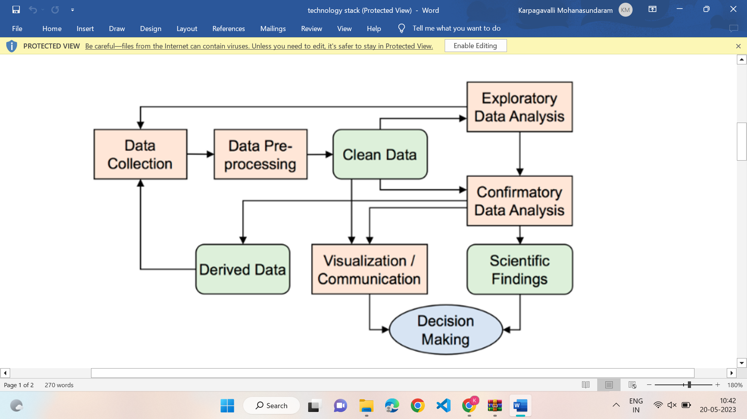

*Figure 1: Architecture of Literacy rate analysis for a better future tomorrow*

**Table-1: Components & Technologies:**

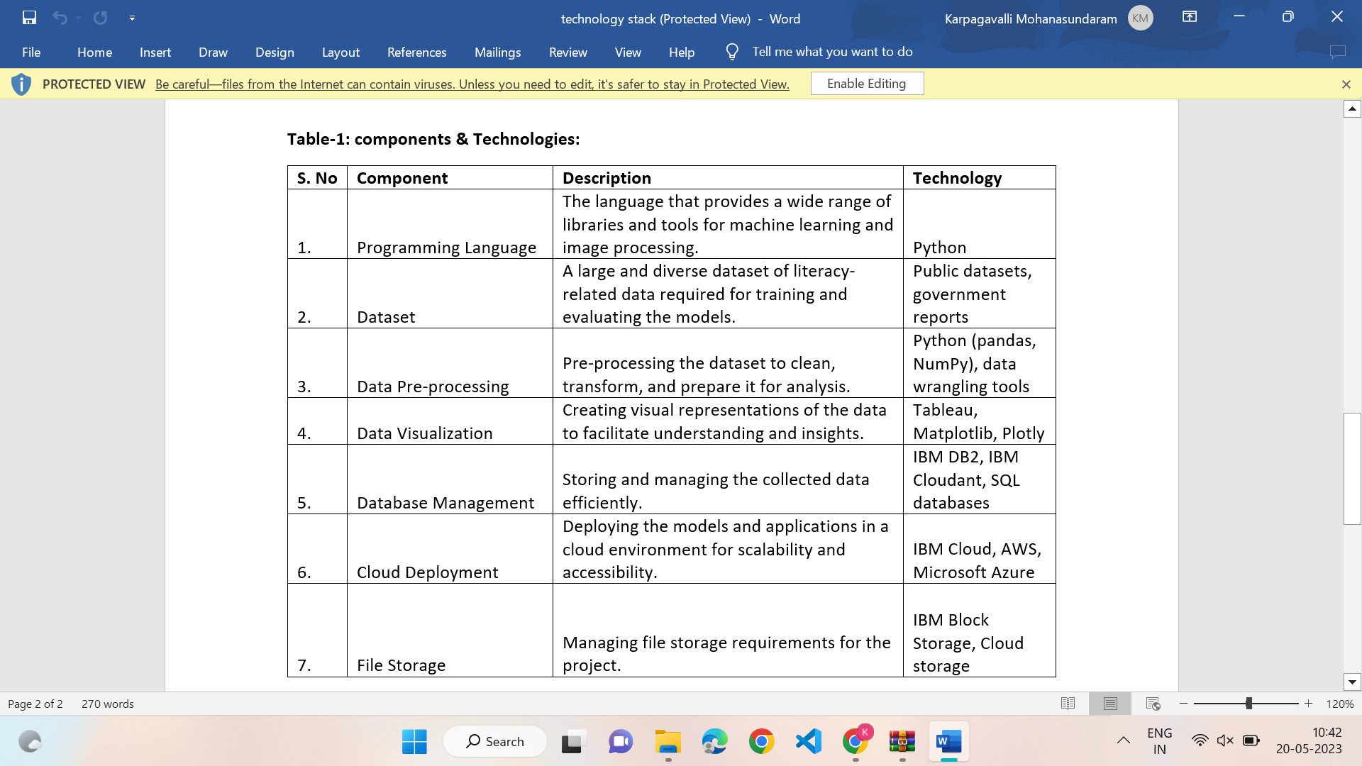

**Table-2: Application Characteristics:**

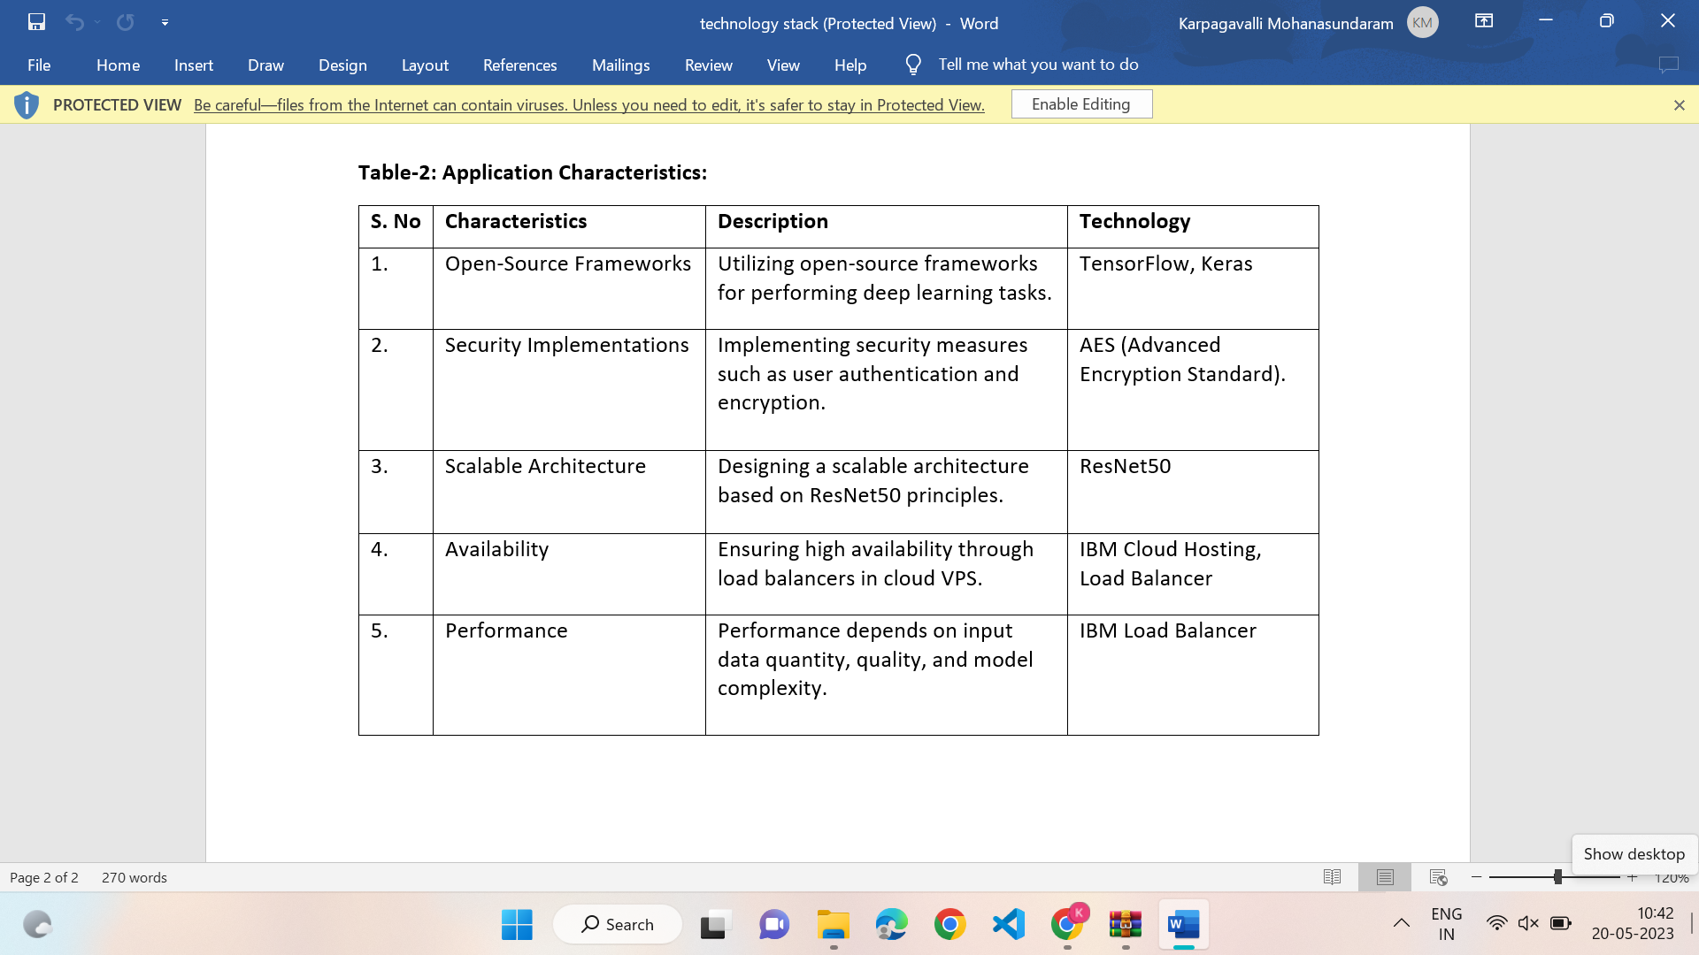

**4.3 User Stories**

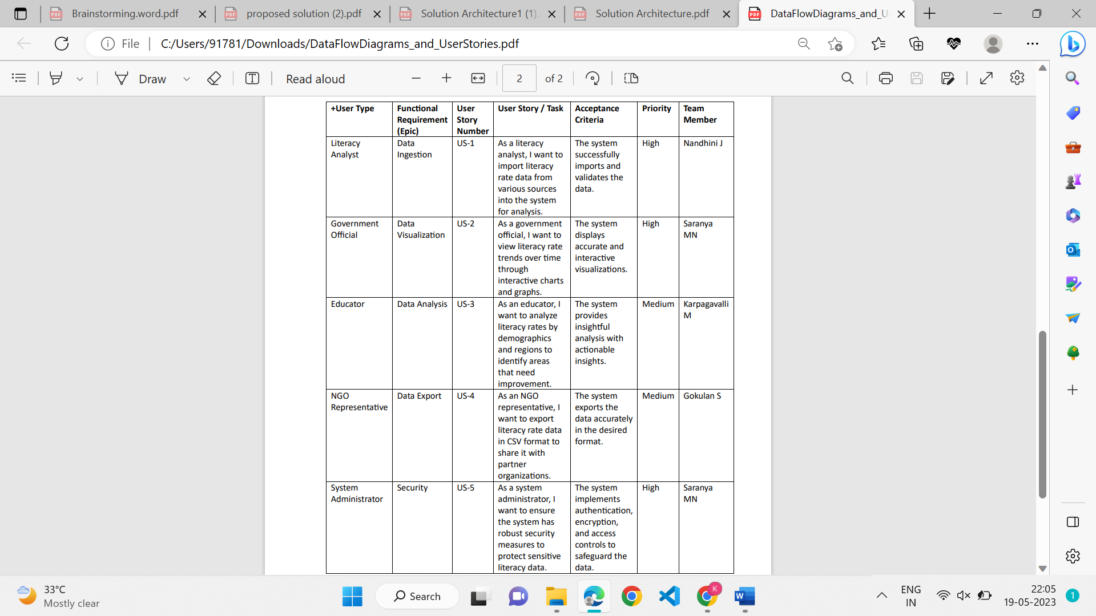

1. **CODING AND SOLUTIONING**

**Feature 1**

Demographic Analysis: The project should consider demographic factors such as age, gender, ethnicity, socioeconomic status, and geographic location in the analysis. This would help identify disparities and understand how different demographic groups are affected by literacy rates.

Geographic Mapping and Visualization: Geographic mapping and visualization tools can be utilized to present the analysis results in an intuitive and visually appealing manner. This can include heat maps, choropleth maps, and interactive visualizations that allow stakeholders to explore literacy rates geographically and understand regional variations.

Socioeconomic Analysis: The project should incorporate socioeconomic analysis to examine the relationship between literacy rates and socioeconomic factors. This can include indicators such as income levels, poverty rates, access to resources, and educational investments to understand the impact of socioeconomic factors on literacy outcomes.

**Feature 2**

Impact Assessment: The project can assess the impact of various interventions and programs aimed at improving literacy rates. This can involve evaluating the effectiveness of specific initiatives, policies, or interventions and identifying best practices for literacy improvement.

Predictive Modeling: Predictive modeling techniques can be employed to forecast future literacy rates based on historical data and identified trends. This can assist policymakers in making informed decisions and allocating resources effectively to achieve desired literacy outcomes.

**6. RESULTS**

**6.1 Performance Metrics**

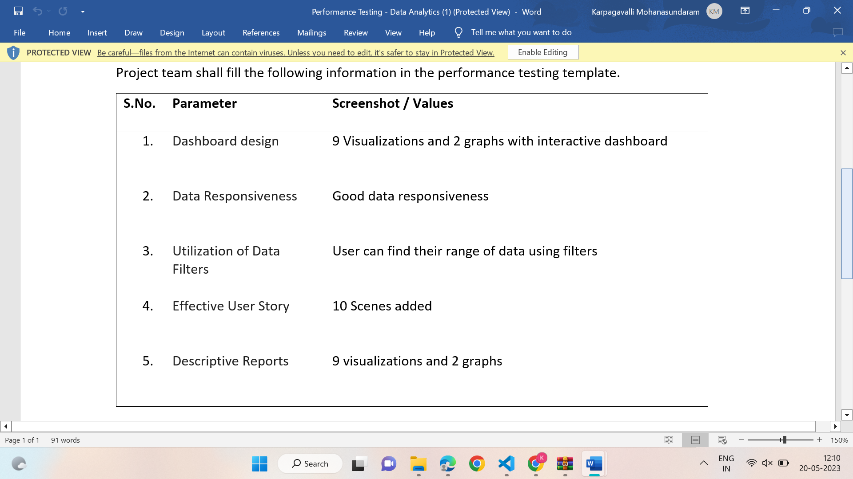

**7. ADVANTAGES & DISADVANTAGES**

**ADVANTAGES :**

1. Informed Decision Making: The project provides valuable insights and data-driven analysis on literacy rates, enabling policymakers, educators, and stakeholders to make informed decisions regarding literacy improvement strategies and resource allocation.

2. Targeted Interventions: Through the analysis of demographic factors, the project can identify specific groups or regions with low literacy rates, allowing for targeted interventions and tailored programs to address their unique needs.

3. Policy Recommendations: The project generates evidence-based recommendations for policy changes and educational reforms to improve literacy outcomes. These recommendations can influence decision-making processes and contribute to long-term systemic improvements.

4. Resource Optimization: By analyzing the factors affecting literacy rates, the project helps optimize resource allocation by identifying areas where investment in educational infrastructure, teacher training, or community engagement would have the most significant impact.

5. Equity and Inclusion: The project can shed light on literacy disparities among different demographic groups, such as gender, socioeconomic status, or ethnic background. This knowledge allows for targeted interventions to promote equity and inclusion in literacy education.

6. Long-term Impact: By analyzing historical trends and conducting time series analysis, the project can provide insights into the effectiveness of past literacy programs and interventions, informing the development of sustainable, evidence-based strategies for long-term impact.

7. Collaboration and Partnerships: The project encourages collaboration among stakeholders, including government agencies, educational institutions, NGOs, and community organizations. This collaboration fosters a holistic approach to literacy improvement, leveraging the strengths and resources of different entities.

8. Public Awareness and Engagement: The project can raise public awareness about the importance of literacy and its impact on individuals and communities. Through educational campaigns and community engagement initiatives, it encourages a collective effort to improve literacy rates and fosters a culture of lifelong learning.

9. Evidence for Funding and Advocacy: The project provides data and analysis that can support funding proposals and advocacy efforts aimed at securing resources and support for literacy programs. The evidence-based approach strengthens the case for investment in literacy education.

10. Monitoring and Evaluation: The project establishes metrics and evaluation mechanisms to monitor the progress of literacy improvement efforts. This allows for ongoing assessment, identification of successful strategies, and adjustments to ensure the effectiveness of interventions over time.

11. Replicability and Scalability: The project's findings, recommendations, and best practices can be shared and replicated in other regions or countries facing similar literacy challenges, allowing for scalability and wider impact beyond the initial target area.

**DISADVANTAGES :**

1. Data Limitations: The project may face challenges related to the availability, quality, and reliability of data sources. Inaccurate or incomplete data can affect the accuracy and validity of the analysis, potentially leading to biased or misleading findings.

2. Data Privacy Concerns: Collecting and analyzing data on literacy rates and demographics may involve handling sensitive personal information. Ensuring data privacy and complying with relevant data protection regulations can be complex and time-consuming, requiring appropriate safeguards and protocols.

3. Limited Generalizability: The project's findings and recommendations may be specific to the target region or population under study. Translating the results to other contexts or regions with different socio-cultural and economic factors may require careful consideration and adaptation.

4. Implementation Challenges: While the project may provide valuable insights and recommendations, the actual implementation of literacy improvement strategies can encounter various challenges. These can include budget constraints, bureaucratic hurdles, resistance to change, and limited resources, which can hinder the successful execution of recommended interventions.

5. Human Bias and Interpretation: Data analysis involves subjective decisions and interpretations made by data analysts and researchers. Unconscious biases or preconceived notions can influence the analysis process, potentially leading to skewed results or misinterpretations.

6. Stakeholder Resistance: Implementing recommended policy changes or interventions can face resistance from stakeholders who may have conflicting interests or different priorities. Overcoming resistance and gaining buy-in from key stakeholders may require effective communication and persuasive efforts.

7. Time and Resource Constraints: Conducting a comprehensive analysis of literacy rates and developing evidence-based recommendations can be a time-consuming and resource-intensive process. Limited timeframes, tight budgets, and competing priorities can pose constraints on the project's scope and outcomes.

8. Unforeseen External Factors: The project's analysis and recommendations may not account for unforeseen external factors or events that can impact literacy rates, such as natural disasters, economic downturns, or political instability. Adapting to such factors and adjusting strategies accordingly can pose challenges.

9. Lack of Engagement and Follow-up: The project's impact may be limited if there is insufficient engagement from relevant stakeholders in implementing the recommended interventions. Follow-up and continuous monitoring of progress are essential to ensure the sustained effectiveness of literacy improvement efforts.

10. Ethical Considerations: The project must navigate ethical considerations, such as ensuring informed consent, protecting participant privacy, and addressing potential biases in data collection and analysis. Failure to address these ethical concerns can undermine the project's credibility and ethical integrity.

**8. CONCLUSION**

In conclusion, the data analytics project titled "Empowering The Future: A Literacy Rate Analysis For A Better Future Tomorrow" holds significant potential for creating positive change and impact. By leveraging data and analysis, the project aims to address the challenges and disparities in literacy rates, ultimately working towards a better future for individuals and communities.

Through its comprehensive analysis of literacy rates, demographic factors, and educational resources, the project provides valuable insights that can inform decision-making, policy changes, and targeted interventions. By understanding the factors influencing literacy outcomes, stakeholders can allocate resources effectively, develop evidence-based strategies, and promote equity and inclusion in education.

While the project faces certain challenges, such as data limitations, privacy concerns, and implementation obstacles, these can be overcome through careful planning, collaboration, and adherence to ethical standards. By addressing these potential drawbacks and leveraging the project's advantages, including informed decision-making, resource optimization, and long-term impact, the project can make significant strides in improving literacy rates and fostering a brighter future.

Ultimately, the success of the project relies on collaboration among stakeholders, including policymakers, educators, researchers, and communities, to collectively work towards the shared goal of enhancing literacy outcomes. By embracing the project's findings, recommendations, and best practices, it is possible to empower individuals, promote lifelong learning, and create a more equitable and prosperous future for generations to come.

**9. FUTURE SCOPE**

1. Longitudinal Analysis: The project can evolve to include long-term monitoring and analysis of literacy rates over time. By collecting and analyzing data at regular intervals, it can track progress, identify trends, and assess the effectiveness of interventions implemented to improve literacy rates.

2. Comparative Studies: The project can extend its scope to include comparative studies between different regions or countries. By comparing literacy rates, educational policies, and socio-economic factors, the project can uncover insights into successful strategies and best practices, facilitating knowledge sharing and cross-learning.

3. Impact Evaluation: Building upon the analysis of literacy rates, the project can incorporate impact evaluation methodologies to assess the direct and indirect impacts of literacy improvement programs. This would involve measuring outcomes such as educational attainment, employment rates, and social empowerment resulting from improved literacy.

4. Predictive Analytics: The project can incorporate predictive analytics techniques to forecast future literacy rates based on historical data and identified trends. This would provide valuable insights for policymakers to anticipate future challenges and proactively develop strategies to address them.

5. Technology Integration: Leveraging advancements in technology, the project can explore the integration of emerging technologies like artificial intelligence (AI), machine learning (ML), and natural language processing (NLP) to enhance data analysis capabilities, automate processes, and extract deeper insights from unstructured data sources such as text documents, social media, and online content.

6. Intervention Design and Testing: The project can expand its focus to include the design and testing of innovative interventions aimed at improving literacy rates. By collaborating with educators, researchers, and policymakers, it can contribute to the development and evaluation of evidence-based interventions, such as digital learning platforms, adaptive learning technologies, or community engagement programs.

7. Stakeholder Engagement and Collaboration: The project can actively engage and collaborate with a wider range of stakeholders, including non-governmental organizations (NGOs), community-based organizations, and private sector entities. This collaborative approach can foster partnerships, share resources, and leverage diverse expertise to maximize the impact of literacy improvement initiatives.

8. Multi-dimensional Analysis: The project can extend its analysis beyond literacy rates to encompass other dimensions of education, such as numeracy skills, digital literacy, and critical thinking. This broader analysis would provide a more comprehensive understanding of the educational landscape and enable a holistic approach to educational improvement.

9. Policy Advocacy: Building on its research and analysis, the project can engage in policy advocacy by actively participating in policy dialogues, contributing to policy formulation, and advocating for evidence-based educational policies that address literacy challenges and promote educational equity.

10. Global Collaboration and Knowledge Sharing: The project can explore opportunities for international collaboration and knowledge sharing. By partnering with global organizations, participating in conferences, and contributing to research networks, the project can exchange insights, methodologies, and lessons learned with other countries facing similar literacy challenges.

By embracing these future scopes, the project "Empowering The Future: A Literacy Rate Analysis For A Better Future Tomorrow" can continue to make significant contributions to literacy improvement efforts, drive evidence-based decision-making, and foster positive educational transformations for individuals and societies.

**10. APPENDIX**

**Source Code**

**Index**

<!DOCTYPE html>

<html lang="en">

<head>

<meta charset="utf-8">

<meta content="width=device-width, initial-scale=1.0" name="viewport">

<title>Literacy Rate</title>

<meta content="" name="description">

<meta content="" name="keywords">

<!-- Favicons -->

<link href="assets/img/favicon.png" rel="icon">

<link href="assets/img/apple-touch-icon.png" rel="apple-touch-icon">

<!-- Google Fonts -->

<link href="https://fonts.googleapis.com/css?family=Open+Sans:300,300i,400,400i,600,600i,700,700i|Krub:300,300i,400,400i,500,500i,600,600i,700,700i|Poppins:300,300i,400,400i,500,500i,600,600i,700,700i" rel="stylesheet">

<!-- Vendor CSS Files -->

<link href="assets/vendor/aos/aos.css" rel="stylesheet">

<link href="assets/vendor/bootstrap/css/bootstrap.min.css" rel="stylesheet">

<link href="assets/vendor/bootstrap-icons/bootstrap-icons.css" rel="stylesheet">

<link href="assets/vendor/boxicons/css/boxicons.min.css" rel="stylesheet">

<link href="assets/vendor/glightbox/css/glightbox.min.css" rel="stylesheet">

<link href="assets/vendor/swiper/swiper-bundle.min.css" rel="stylesheet">

</head>

<body>

<!-- ======= Header ======= -->

<header id="header" class="fixed-top">

<div class="container d-flex align-items-center justify-content-between">

<h1 class="logo"><a href="index.html">Education in india</a></h1>

<!-- Uncomment below if you prefer to use an image logo -->

<!-- <a href="index.html" class="logo"><img src="assets/img/logo.png" alt="" class="img-fluid"></a>-->

<nav id="navbar" class="navbar">

<ul>

<li><a class="nav-link scrollto active" href="#hero">Home</a></li>

<li><a class="nav-link scrollto" href="#about">About</a></li>

<li><a class="nav-link scrollto" href="#dashboard">Dashboard</a></li>

<li><a class="nav-link scrollto " href="#story">Story</a></li>

<li><a class="nav-link scrollto" href="#report">Report</a></li>

<i class="bi bi-list mobile-nav-toggle"></i>

</nav><!-- .navbar -->

</div>

</header><!-- End Header -->

<!-- ======= Hero Section ======= -->

<section id="hero" class="d-flex align-items-center">

<div class="container d-flex flex-column align-items-center justify-content-center" data-aos="fade-up">

<h1>Analysis of Literacy Rate in India</h1>

<h2>According to the National Literacy Mission programme, a person must attain the skills of reading, writing and arithmetic to be entitled as literate.The programme aims to gather comprehensive data on literacy rates and identify the factors influencing literacy levels</h2>

<a href="#about" class="btn-get-started scrollto">Get Started</a>

<img src="https://tse1.mm.bing.net/th?id=OIP.HNah_Da8vgUr3jWsqxfR6QHaE8&pid=Api&P=0&h=180" class="img-fluid hero-img" alt="" data-aos="zoom-in" data-aos-delay="150">

</div>

</section><!-- End Hero -->

<main id="main">

<!-- ======= About Section ======= -->

<!-- End About Section -->

<!-- ======= Clients Section ======= -->

<!-- End Clients Section -->

<!-- ======= Features Section ======= -->

<section id="dashboard" class="features" data-aos="fade-up">

<div class="container">

<div class="section-title">

<h3>Dashboard</h3>

<iframe src="https://ap1.ca.analytics.ibm.com/bi/?perspective=dashboard&amp;pathRef=.my_folders%2Fliteratedashboard&amp;closeWindowOnLastView=true&amp;ui_appbar=false&amp;ui_navbar=false&amp;shareMode=embedded&amp;action=view&amp;mode=dashboard&amp;subView=model00000188192cdce8_00000002" width="1350" height="900" frameborder="0" gesture="media" allow="encrypted-media" allowfullscreen=""></iframe>

</div>

</div>

</section><!-- End Features Section -->

<!-- ======= Steps Section ======= -->

<!-- End Steps Section -->

<!-- ======= Services Section ======= -->

<section id="story" class="services">

<div class="container" data-aos="fade-up">

<div class="section-title">

<h2>Story</h2>

</div>

<iframe src="https://ap1.ca.analytics.ibm.com/bi/?perspective=story&amp;pathRef=.my_folders%2FLitstory&amp;closeWindowOnLastView=true&amp;ui_appbar=false&amp;ui_navbar=false&amp;shareMode=embedded&amp;action=view&amp;sceneId=model0000018824e8e0c2_00000000&amp;sceneTime=5000" width="1350" height="900" frameborder="0" gesture="media" allow="encrypted-media" allowfullscreen=""></iframe>

</div>

</section><!-- End Services Section -->

<!-- ======= Portfolio Section ======= -->

<section id="portfolio" class="portfolio">

<div class="container" data-aos="fade-up">

<div class="section-title">

<h2>Report</h2>

</div>

<iframe src="https://ap1.ca.analytics.ibm.com/bi/?pathRef=.my_folders%2FNew%2Breport&amp;closeWindowOnLastView=true&amp;ui_appbar=false&amp;ui_navbar=false&amp;shareMode=embedded&amp;action=run&amp;format=HTML&amp;prompt=false" width="1350" height="600" frameborder="0" gesture="media" allow="encrypted-media" allowfullscreen=""></iframe>

</div>

</section>

<!-- End Portfolio Section -->

<!-- ======= Team Section ======= -->

<section id="team" class="team">

<div class="container" data-aos="fade-up">

<div class="section-title">

<h2>Literacy Rate in India</h2>

<p>Education plays a crucial role in empowering individuals, eradicating poverty, and fostering socio-economic development. The current literacy rate in India is approximately 77.7% (as of 2021).There are regional disparities in literacy rates across India. Some states have achieved higher literacy rates, while others lag behind</p>

</div>

<div class="row">

<div class="col-xl-3 col-lg-4 col-md-6" data-aos="fade-up" data-aos-delay="100">

<div class="member"><br>

<img src="https://static.langimg.com/thumb/msid-77992621,imgsize-437696,width-700,height-390,resizemode-75/navbharat-times.jpg" class="img-fluid" alt="">

<div class="member-info">

</div>

</div>

</div>

<div class="col-xl-3 col-lg-4 col-md-6" data-aos="fade-up" data-aos-delay="200">

<div class="member">

<img src="https://tse3.mm.bing.net/th?id=OIP.cLDm96ShDJI5J8Y_wpFNtAAAAA&pid=Api&P=0&h=180" class="img-fluid" alt="">

</div>

</div>

<div class="col-xl-3 col-lg-4 col-md-6" data-aos="fade-up" data-aos-delay="300">

<div class="member">

<img src="https://tse3.mm.bing.net/th?id=OIP.xHGmRDfML1RSCLFiJ2WpSwHaE8&pid=Api&P=0&h=180" class="img-fluid" alt="">

</div>

</div>

<div class="col-xl-3 col-lg-4 col-md-6" data-aos="fade-up" data-aos-delay="400">

<div class="member">

<img src="https://tse3.mm.bing.net/th?id=OIF.hOcxntBzs9Z1MHoxCMzf4A&pid=Api&P=0&w=300&h=300" class="img-fluid" alt="">

<div class="member-info">

<div class="member-info-content">

</div>

</div>

</div>

</div>

</div>

</section><!-- End Team Section -->

<!-- about page -->

<!-- end about page -->

<!-- ======= Pricing Section ======= -->

<!-- End Pricing Section -->

<!-- ======= Frequently Asked Questions Section ======= -->

<!-- End Frequently Asked Questions Section -->

<!-- ======= Contact Section ======= -->

<!-- End Contact Section -->

</main><!-- End #main -->

<!-- ======= Footer ======= -->

<footer id="footer">

<div class="footer-top">

<div class="container">

<div class="row">

<!-- All the links in the footer should remain intact. -->

<!-- You can delete the links only if you purchased the pro version. -->

<!-- Licensing information: https://bootstrapmade.com/license/ -->

<!-- Purchase the pro version with working PHP/AJAX contact form: https://bootstrapmade.com/bikin-free-simple-landing-page-template/ -->

Designed by <a href="https://bootstrapmade.com/">Student</a>

</div>

</div>

<div class="social-links text-center text-md-right pt-3 pt-md-0">

<a href="#" class="twitter"><i class="bx bxl-twitter"></i></a>

<a href="#" class="facebook"><i class="bx bxl-facebook"></i></a>

<a href="#" class="instagram"><i class="bx bxl-instagram"></i></a>

<a href="#" class="google-plus"><i class="bx bxl-skype"></i></a>

<a href="#" class="linkedin"><i class="bx bxl-linkedin"></i></a>

</div>

</div>

</footer><!-- End Footer -->

<div id="preloader"></div>

<a href="#" class="back-to-top d-flex align-items-center justify-content-center"><i class="bi bi-arrow-up-short"></i></a>

<!-- Vendor JS Files -->

<script src="assets/vendor/aos/aos.js"></script>

<script src="assets/vendor/bootstrap/js/bootstrap.bundle.min.js"></script>

<script src="assets/vendor/glightbox/js/glightbox.min.js"></script>

<script src="assets/vendor/isotope-layout/isotope.pkgd.min.js"></script>

<script src="assets/vendor/swiper/swiper-bundle.min.js"></script>

<script src="assets/vendor/php-email-form/validate.js"></script>

<!-- Template Main JS File -->

<script src="assets/js/main.js"></script>

</body>

</html>

**Main.js**

function() {

"use strict";

/**

* Easy selector helper function

*/

const select = (el, all = false) => {

el = el.trim()

if (all) {

return [...document.querySelectorAll(el)]

} else {

return document.querySelector(el)

}

}

/**

* Easy event listener function

*/

const on = (type, el, listener, all = false) => {

let selectEl = select(el, all)

if (selectEl) {

if (all) {

selectEl.forEach(e => e.addEventListener(type, listener))

} else {

selectEl.addEventListener(type, listener)

}

}

}

/**

* Easy on scroll event listener

*/

const onscroll = (el, listener) => {

el.addEventListener('scroll', listener)

}

/**

* Navbar links active state on scroll

*/

let navbarlinks = select('#navbar .scrollto', true)

const navbarlinksActive = () => {

let position = window.scrollY + 200

navbarlinks.forEach(navbarlink => {

if (!navbarlink.hash) return

let section = select(navbarlink.hash)

if (!section) return

if (position >= section.offsetTop && position <= (section.offsetTop + section.offsetHeight)) {

navbarlink.classList.add('active')

} else {

navbarlink.classList.remove('active')

}

})

}

window.addEventListener('load', navbarlinksActive)

onscroll(document, navbarlinksActive)

/**

* Scrolls to an element with header offset

*/

const scrollto = (el) => {

let header = select('#header')

let offset = header.offsetHeight

let elementPos = select(el).offsetTop

window.scrollTo({

top: elementPos - offset,

behavior: 'smooth'

})

}

/**

* Back to top button

*/

let backtotop = select('.back-to-top')

if (backtotop) {

const toggleBacktotop = () => {

if (window.scrollY > 100) {

backtotop.classList.add('active')

} else {

backtotop.classList.remove('active')

}

}

window.addEventListener('load', toggleBacktotop)

onscroll(document, toggleBacktotop)

}

/**

* Mobile nav toggle

*/

on('click', '.mobile-nav-toggle', function(e) {

select('#navbar').classList.toggle('navbar-mobile')

this.classList.toggle('bi-list')

this.classList.toggle('bi-x')

})

/**

* Mobile nav dropdowns activate

*/

on('click', '.navbar .dropdown > a', function(e) {

if (select('#navbar').classList.contains('navbar-mobile')) {

e.preventDefault()

this.nextElementSibling.classList.toggle('dropdown-active')

}

}, true)

/**

* Scrool with ofset on links with a class name .scrollto

*/

on('click', '.scrollto', function(e) {

if (select(this.hash)) {

e.preventDefault()

let navbar = select('#navbar')

if (navbar.classList.contains('navbar-mobile')) {

navbar.classList.remove('navbar-mobile')

let navbarToggle = select('.mobile-nav-toggle')

navbarToggle.classList.toggle('bi-list')

navbarToggle.classList.toggle('bi-x')

}

scrollto(this.hash)

}

}, true)

/**

* Scroll with ofset on page load with hash links in the url

*/

window.addEventListener('load', () => {

if (window.location.hash) {

if (select(window.location.hash)) {

scrollto(window.location.hash)

}

}

});

/**

* Preloader

*/

let preloader = select('#preloader');

if (preloader) {

window.addEventListener('load', () => {

preloader.remove()

});

}

/**

* Porfolio isotope and filter

*/

window.addEventListener('load', () => {

let portfolioContainer = select('.portfolio-container');

if (portfolioContainer) {

let portfolioIsotope = new Isotope(portfolioContainer, {

itemSelector: '.portfolio-item'

});

let portfolioFilters = select('#portfolio-flters li', true);

on('click', '#portfolio-flters li', function(e) {

e.preventDefault();

portfolioFilters.forEach(function(el) {

el.classList.remove('filter-active');

});

this.classList.add('filter-active');

portfolioIsotope.arrange({

filter: this.getAttribute('data-filter')

});

portfolioIsotope.on('arrangeComplete', function() {

AOS.refresh()

});

}, true);

}

});

/**

* Initiate portfolio lightbox

*/

const portfolioLightbox = GLightbox({

selector: '.portfolio-lightbox'

});

/**

* Portfolio details slider

*/

new Swiper('.portfolio-details-slider', {

speed: 400,

loop: true,

autoplay: {

delay: 5000,

disableOnInteraction: false

},

pagination: {

el: '.swiper-pagination',

type: 'bullets',

clickable: true

}

});

/**

* Testimonials slider

*/

new Swiper('.testimonials-slider', {

speed: 600,

loop: true,

autoplay: {

delay: 5000,

disableOnInteraction: false

},

slidesPerView: 'auto',

pagination: {

el: '.swiper-pagination',

type: 'bullets',

clickable: true

},

breakpoints: {

320: {

slidesPerView: 1,

spaceBetween: 20

},

1200: {

slidesPerView: 3,

spaceBetween: 20

}

}

});

/**

* Animation on scroll

*/

window.addEventListener('load', () => {

AOS.init({

duration: 1000,

easing: 'ease-in-out',

once: true,

mirror: false

})

});

})()

**App.py**

from flask import Flask, render_template

app = Flask(__name__)

@app.route('/', methods=["GET","POST"])

def home():

return render_template('index.html')

**GitHub & Project Video Demo Link**

**GitHub Link**

[**https://github.com/naanmudhalvan-SI/PBL-NT-GP-NM2023TMID21570-8141-1682403235**](https://github.com/naanmudhalvan-SI/PBL-NT-GP-NM2023TMID21570-8141-1682403235)

**Project Video Demo Link https://drive.google.com/file/d/17IdyeIqycyTiHW2oJBui9LhBOj7Ue4CV/view?usp=sharing**